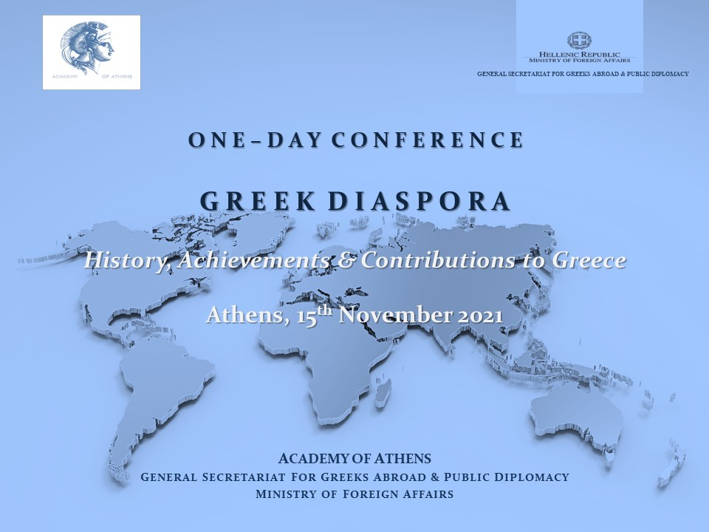

About Conference Objectives

Τhe pivotal role of the Greek Diaspora regarding the planning and implementation of the national liberation struggle has been highlighted within the framework of the celebrations for the Bicentenial of the Greek Revolution. Since then, the Greek Diaspora has decisively contributed through various actions, within Greece but also in many countries worldwide, to the battles for survival of the Greek state.
The role of the Diaspora for Greece remains equally important today, concerning Hellenism as a whole, inside and outside the country. This applies particularly to the hoped-for prospect of repatriation of more than 500.000 Greek citizens that have left their homeland during the past decade, depriving Greece of a crucial source of human potential and talent.
On that basis, this initial conference mainly aims at focusing and emphasizing the goal “Connecting to Greece: How Greek Diaspora views Greece and how Greece perceives the Diaspora”. The program of presentations is structured along the lines of the three sections of the Academy: Physical Sciences, Ethical and Political Sciences, as well as Letters and the Fine Arts.

C O N F E R E N C E S C H E D U L E

GREEK DIASPORA –
HISTORY, ACHIEVEMENTS & CONTRIBUTIONS TO GREECE

15th NOVEMBER 2021
ACADEMY OF ATHENS MEGARON
28 PANEPISTIMIOU STR., ATHENS

08.30 – 09.00 Reception & Registration

09.00 – 10.30 WELCOME REMARKS // CONFERENCE OBJECTIVES/PLENARY TALK
Chairs: Christos Zerefos, Dimitris Nanopoulos, Academicians

09.00 – 09.10 Loukas Christoforou, President of Academy of Athens
Welcome Address

09.10 – 09.20 Andreas Katsaniotis, Deputy Minister of Foreign Affairs for Diaspora Greeks
Welcome Address

09.30 – 09.30 Stamatios M. Krimizis, Member of Academy of Athens, Conference Coordinator
Conference Objectives

09.30 – 10.15 Ioannis Chassiotis, Professor Emeritus of Aristotle University of Thessaloniki
Greek Diaspora: A perpetually open chapter of our national History

10:15-10:30 Questions and Discussion

10:30-11:00 Break

11.00 – 12.30 LETTERS & FINE ARTS
Chairs: Chryssa Maltezou, Theodoros Papaggelis, Academicians

11.00 – 11.30 Dinos Siotis, Poet, Publisher of ‘Decata’ Journal
Greek Poetry in North America in the 20th century

11.30 – 12.00 Maria Makraki, Camerata Europaea, Berlin (conductor, artistic director)
Fine Arts in the Diaspora

12.00 – 12.30 Alexandros Kitroef, Haverford College
Historiography of Modern and Contemporary Greece in the Diaspora

12.30 – 13.30 Break

13.30 – 15.00 PHYSICAL SCIENCES
Chairs: Georgios Kollias, Antonios Kounadis, Academicians

13.30 – 14.00 Stylianos Antonarakis, Université de Genève, corresponding member of
Academy of Athens
Greek Diaspora’s contribution to Biomedical Research

14.00 – 14.30 Ioannis Iliopoulos, Ecole Normale Supérieure, French Axademy
International Presence in Mathematics and Physical Sciences

14.30 – 15.00 Ioannis Kevrekidis, Johns Hopkins University, Bloomberg Professor of Engineering, US National Academy of Engineering
International Presence in Engineering Sciences

15:00-15:30 Break

15.30 – 17.45 ETHICS & POLITICAL SCIENCES
Chairs: Anna Bennaki - Psarouda, Vasileios Rapanos, Loukas Papadimos, Academicians

15.30 – 16.00 Ioannis Ioannidis, Professor of Economics, Tufts University, corresponding
member of Academy of Athens
Greek Diaspora in Economics: Europe, USA and its Role in Greece

16.00 – 16.30 Van Koufoudakis, American Hellenic Institute, Professor Emeritus
Indiana University-Purdue University, Intercollege Nicosia, Cyprus
Diaspora presence in Political Sciences/ Management/Enterpreneurship

16.30 – 17.00 Vasileios Skouris, former President, European Court of Justice, Professor
Emeritus of Public Law, Aristotle University of Thessaloniki, corresponding
member of Academy of Athens
Presence of Greek Diaspora in Law and legal professions

17.00 – 17.45 Loukas Christoforou, President of Academy of Athens
Ioannis Chrysoulakis, General Secretary for Greeks Abroad and Public
Diplomacy, Ministry of Foreign Affairs
Conference Summary and Conclusions

